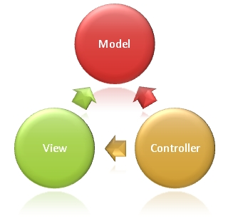

**The Model** is the part of the application that handles the logic for the application data.  
Often model objects retrieve data (and store data) from a database.

**The View** is the parts of the application that handles the display of the data.  
Most often the views are created from the model data.

**The Controller** is the part of the application that handles user interaction.  
Typically controllers read data from a view, control user input, and send input data to the model.

**(http://www.w3schools.com/aspnet/mvc_intro.asp)**

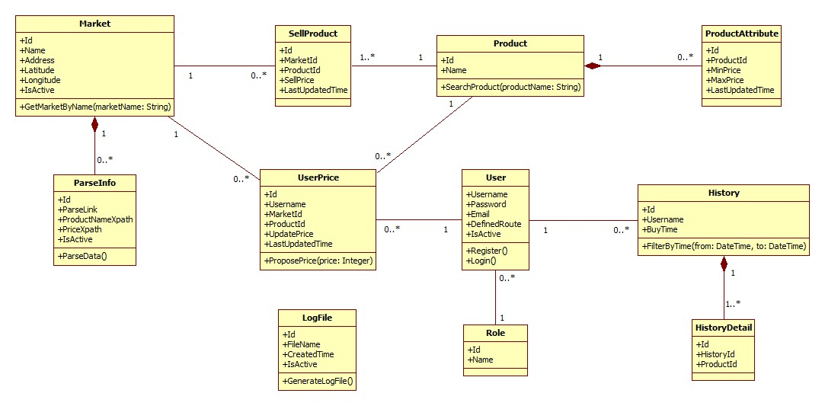

1. **Market**

Attribute

|  |  |  |  |
| --- | --- | --- | --- |
| Attribute | Type | Visibility | Description |
| Id | Integer | Public | Unique identifier of each market |
| Name | String | Public | Name of market |
| Address | String | Public | Address of market |
| Longitude | Double | Public | Longitude of market |
| IsActive | Boolean | Public | Status of market |

Method

|  |  |  |  |
| --- | --- | --- | --- |
| Method | Return type | Visibility | Description |
| GetMarketByName | List of markets | Public | Find market by its name |

1. **ParseInfo**

Attribute

|  |  |  |  |
| --- | --- | --- | --- |
| Attribute | Type | Visibility | Description |
| Id | Integer | Public | Unique identifier of each item |
| ParseLink | String | Public | Link used to parse |
| ProductNameXpath | String | Public | Xpath to get the name of products |
| PriceXpath | String | Public | Xpath to get the price of products |
| IsActive | Boolean | Public | Status of info |

Method

|  |  |  |  |
| --- | --- | --- | --- |
| Method | Return type | Visibility | Description |
| ParseData | Void | Public | Run parser to get data |

1. **SellProduct**

Attribute

|  |  |  |  |
| --- | --- | --- | --- |
| Attribute | Type | Visibility | Description |
| Id | Integer | Public | Unique identifier of each item |
| MarketId | Integer | Public | Id of market |
| ProductId | Integer | Public | Id of product |
| SellPrice | Integer | Public | That market sells that product at this price |
| LastUpdatedTime | DateTime | Public | The time when the price is updated. |

1. **Product**

Attribute

|  |  |  |  |
| --- | --- | --- | --- |
| Attribute | Type | Visibility | Description |
| Id | Integer | Public | Unique identifier of each product |
| Name | Integer | Public | Product name |

Method

|  |  |  |  |
| --- | --- | --- | --- |
| Method | Return type | Visibility | Description |
| SearchProduct | List of products | Public | Search product by its name |

1. **ProductAttribute**

Attribute

|  |  |  |  |
| --- | --- | --- | --- |
| Attribute | Type | Visibility | Description |
| Id | Integer | Public | Unique identifier of each item |
| ProductId | Integer | Public | Id of product |
| MinPrice | Integer | Public | Min price of this product |
| MaxPrice | Integer | Public | Max price of this product |
| LastUpdatedTime | DateTime | Public | The time when this information is updated. |

1. **UserPrice**

Attribute

|  |  |  |  |
| --- | --- | --- | --- |
| Attribute | Type | Visibility | Description |
| Id | Integer | Public | Unique identifier of each item |
| Username | String | Public | Username of member who propose price |
| MarketId | Integer | Public | Id of market |
| ProductId | Integer | Public | Id of product |
| UpdatePrice | Integer | Public | Proposed price |
| LastUpdatedTime | DateTime | Public | The time when the price is proposed. |

Method

|  |  |  |  |
| --- | --- | --- | --- |
| Method | Return type | Visibility | Description |
| ProposePrice | Void | Public | Propose price for the system |

1. **User**

Attribute

|  |  |  |  |
| --- | --- | --- | --- |
| Attribute | Type | Visibility | Description |
| Username | String | Public | Username for each user |
| Password | String | Public | User’s password |
| Email | String | Public | User’s email |
| DefinedRoute | String | Public | The route which user defines |
| IsActive | Boolean | Public | Status of this account |

Method

|  |  |  |  |
| --- | --- | --- | --- |
| Method | Return type | Visibility | Description |
| Register | Void | Public | For new user to register |
| Login | Boolean | Public | Used to log in the system |

1. **History**

Attribute

|  |  |  |  |
| --- | --- | --- | --- |
| Attribute | Type | Visibility | Description |
| Id | Integer | Public | Unique identifier of each history |
| Username | String | Public | Owner of this history |
| BuyTime | DateTime | Public | The time when owner create this history |

Method

|  |  |  |  |
| --- | --- | --- | --- |
| Method | Return type | Visibility | Description |
| FilterByTime | List of history | Public | Filter history list by the range of time |

1. **HistoryDetail**

Attribute

|  |  |  |  |
| --- | --- | --- | --- |
| Attribute | Type | Visibility | Description |
| Id | Integer | Public | Unique identifier of each item |
| HistoryId | Integer | Public | Id of history |
| ProductId | Integer | Public | Id of product |

1. **Role**

Attribute

|  |  |  |  |
| --- | --- | --- | --- |
| Attribute | Type | Visibility | Description |
| Id | Integer | Public | Unique identifier of each role |
| Name | String | Public | Role name |

1. **LogFile**

Attribute

|  |  |  |  |
| --- | --- | --- | --- |
| Attribute | Type | Visibility | Description |
| Id | Integer | Public | Unique identifier of each file |
| FileName | String | Public | File name |
| CreatedTime | DateTime | Public | The time when this file is created |
| IsActive | Boolean | Public | Status of this file |

Method

|  |  |  |  |
| --- | --- | --- | --- |
| Method | Return type | Visibility | Description |
| GenerateLogFile | Boolean | Public | Generate log file for each time system runs the parser |